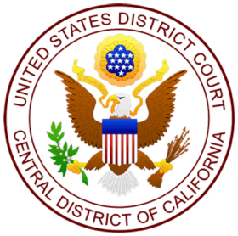

UNITED STATES DISTRICT COURT
CENTRAL DISTRICT OF CALIFORNIA

THE HONORABLE JOSEPHINE L. STATON
UNITED STATES DISTRICT JUDGE
First Street Courthouse – Los Angeles
Courtroom No. 8A

FRIDAY, MARCH 24, 2023

Courtroom Deputy Court Reporter
V.R. Vallery Miranda Algorri

NO. | TIME | CASE INFORMATION | HEARINGS
1 | 8:30 AM | CR 22-00534-JLS: U.S.A. v. Armando Martinez (CUSTODY)  AUSA: Daniel H. Weiner  USPO: Graciela Gudino  DFPD: Gabriela Rivera | Sentencing (Allegations 1-4)
2 | 9:00 AM | SACR 21-00084 (A)-JLS: U.S.A. v. Ian R. Diaz (BOND)  AUSA: Rebecca Ross; Mona Sedky; Marco Palmieri  RTND: Karen Goldstein; Melissa Austen | Jury Trial – 10TH DAY  Deliberations
3 | 9:00 AM | SACR 20-00056-JLS: USA v. Sean Michael Bryant (CUSTODY)  AUSA: Kelly Larocque  USPO: Lillian Smith  DFPD: Andrea L. Jacobs | Preliminary Revocation on Supervised Release Hearing
4 | 9:30 AM | SACR 20-00073-JLS U.S.A. Luis Alfredo Mendoza-Mendez (CUSTODY)  AUSA: Alexander Seth Gorin  USPO: Norma Cordero  DFPD: Andrea L. Jacobs | Preliminary Revocation on Supervised Release Hearing
5 | 11:30 AM | CR 22-00207-JLS: USA v. Michael Alan Stollery (CUSTODY)  P: Tian Huang  D: Andrew Holmes, Ret. | Sentencing
6 | 2:00 PM | SACV 20-02413-JLS (KESx): Valerie Martinez et al v. Equinox Holdings, Inc. et al  P: Omid Nosrati; Rene Maldonado; Patricio Barrera; Michael Bral  D: Clarisse Petersen; Jonathan Schmidt; James Putman Carter | Exhibit Conference

